HomeWork 09 SQL: due 09/25/2019

Part A: Creating Database

CREATE DATABASE "HW09_SQL"

WITH

OWNER = postgres

ENCODING = 'UTF8'

LC_COLLATE = 'English_United States.1252'

LC_CTYPE = 'English_United States.1252'

TABLESPACE = pg_default

CONNECTION LIMIT = -1;

COMMENT ON DATABASE "HW09_SQL"

IS 'Home Work 09 using SQL';

Part B: Creating Needed Tables within the Database

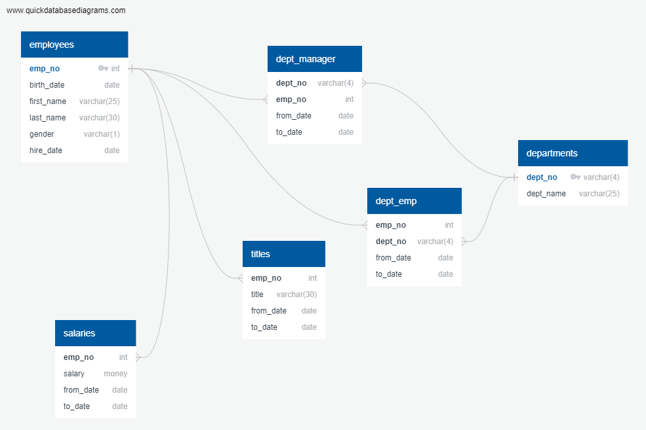

-- Exported from QuickDBD: https://www.quickdatabasediagrams.com/

-- Link to schema: https://app.quickdatabasediagrams.com/#/d/T3VgHJ

-- NOTE! If you have used non-SQL datatypes in your design, you will have to change these here.

CREATE TABLE "employees" (

"emp_no" int NOT NULL,

"birth_date" date NOT NULL,

"first_name" varchar(25) NOT NULL,

"last_name" varchar(30) NOT NULL,

"gender" varchar(1) NOT NULL,

"hire_date" date NOT NULL,

CONSTRAINT "pk_employees" PRIMARY KEY (

"emp_no"

)

);

CREATE TABLE "titles" (

"emp_no" int NOT NULL,

"title" varchar(30) NOT NULL,

"from_date" date NOT NULL,

"to_date" date NOT NULL

);

CREATE TABLE "salaries" (

"emp_no" int NOT NULL,

"salary" money NOT NULL,

"from_date" date NOT NULL,

"to_date" date NOT NULL

);

CREATE TABLE "departments" (

"dept_no" varchar(4) NOT NULL,

"dept_name" varchar(25) NOT NULL,

CONSTRAINT "pk_departments" PRIMARY KEY (

"dept_no"

)

);

CREATE TABLE "dept_emp" (

"emp_no" int NOT NULL,

"dept_no" varchar(4) NOT NULL,

"from_date" date NOT NULL,

"to_date" date NOT NULL

);

CREATE TABLE "dept_manager" (

"dept_no" varchar(4) NOT NULL,

"emp_no" int NOT NULL,

"from_date" date NOT NULL,

"to_date" date NOT NULL

);

ALTER TABLE "titles" ADD CONSTRAINT "fk_titles_emp_no" FOREIGN KEY("emp_no")

REFERENCES "employees" ("emp_no");

ALTER TABLE "salaries" ADD CONSTRAINT "fk_salaries_emp_no" FOREIGN KEY("emp_no")

REFERENCES "employees" ("emp_no");

ALTER TABLE "dept_emp" ADD CONSTRAINT "fk_dept_emp_emp_no" FOREIGN KEY("emp_no")

REFERENCES "employees" ("emp_no");

ALTER TABLE "dept_emp" ADD CONSTRAINT "fk_dept_emp_dept_no" FOREIGN KEY("dept_no")

REFERENCES "departments" ("dept_no");

ALTER TABLE "dept_manager" ADD CONSTRAINT "fk_dept_manager_dept_no" FOREIGN KEY("dept_no")

REFERENCES "departments" ("dept_no");

ALTER TABLE "dept_manager" ADD CONSTRAINT "fk_dept_manager_emp_no" FOREIGN KEY("emp_no")

REFERENCES "employees" ("emp_no");

Resulting Table Structures:

**employees**



**titles**



**salaries**

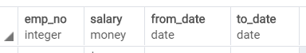

**departments**

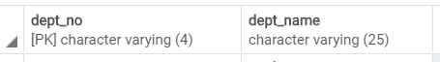

**dept_emp**



**dept_mager**



Another Way to Confirm Existence of Tables: (By using psql Shell)

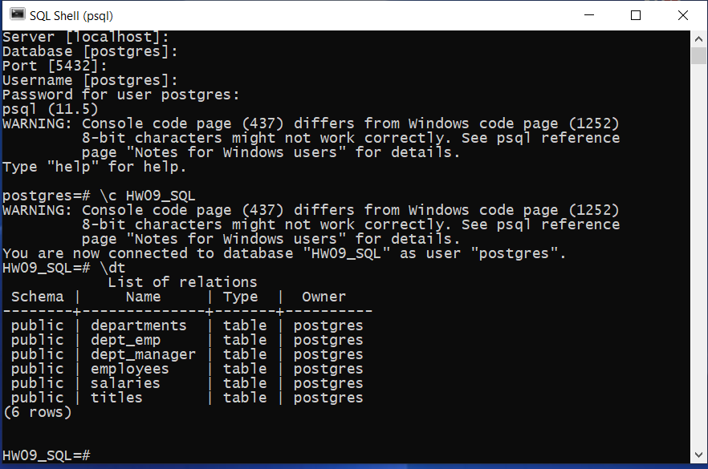

Part C: Running Queries

[1] List the following details of each employee: employee number, last name, first name, gender, and salary.

SELECT e.emp_no, e.last_name, e.first_name, e.gender, s.salary

FROM salaries AS s

INNER JOIN employees AS e ON

e.emp_no=s.emp_no;

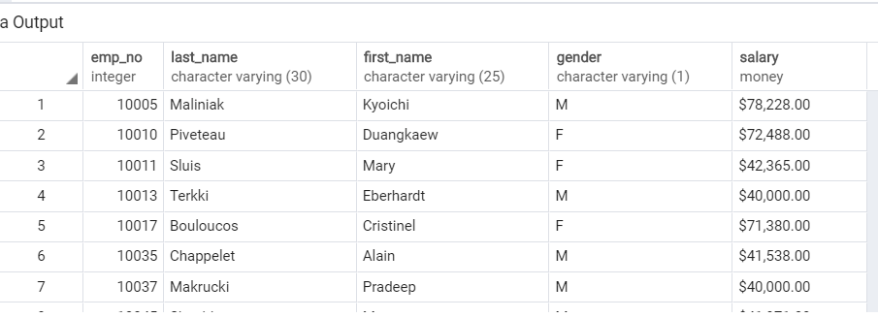

[2] employees hired in 1987

Tried two different approaches and got same results:

SELECT emp_no, last_name, first_name, gender, hire_date

FROM employees

WHERE hire_date BETWEEN'1987-01-01' AND'1987-12-31';

SELECT emp_no, last_name, first_name, gender, hire_date

FROM employees

WHERE extract (year from hire_date)='1987';

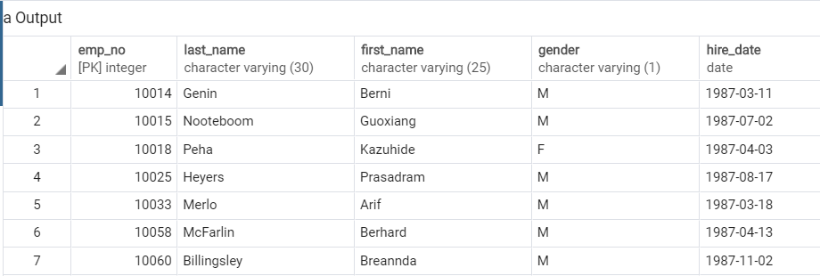

[3] List the manager of each department with the following information: department number, department name, the manager's employee number, last name, first name, and start and end employment dates.

SELECT d.dept_no, d.dept_name, e.emp_no, e.last_name, e.first_name, s.from_date, s.to_date

FROM departments as d

INNER JOIN dept_manager as dm

ON d.dept_no=dm.dept_no

INNER JOIN employees as e

ON dm.emp_no=e.emp_no

INNER JOIN salaries as s

ON e.emp_no=s.emp_no

ORDER BY d.dept_no;

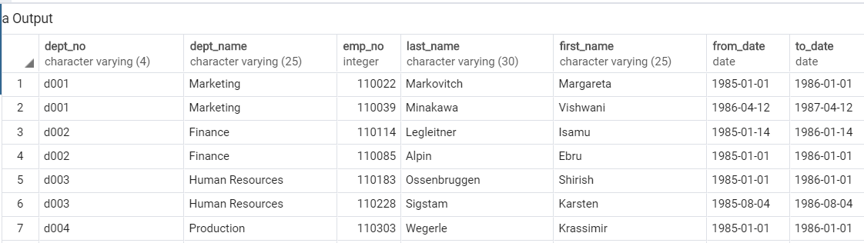

[4] List the department of each employee with the following information: employee number, last name, first name, and department name.

SELECT e.emp_no, e.last_name, e.first_name, d.dept_name

FROM employees as e

INNER JOIN dept_emp de

ON de.emp_no=e.emp_no

INNER JOIN departments as d

ON de.dept_no=d.dept_no

ORDER BY e.last_name;

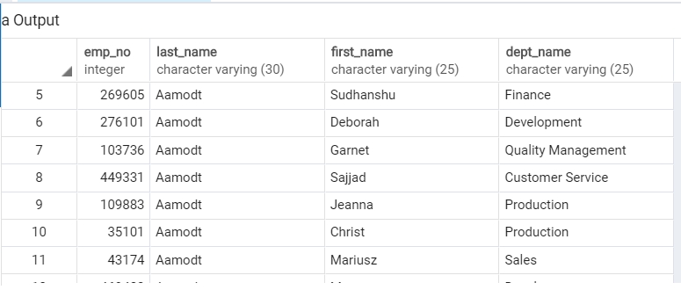

[5] List all employees whose first name is "Duangkaew" and last names begin with "P."

SELECT * FROM employees

WHERE first_name='Duangkaew' and left(last_name,1)='P';

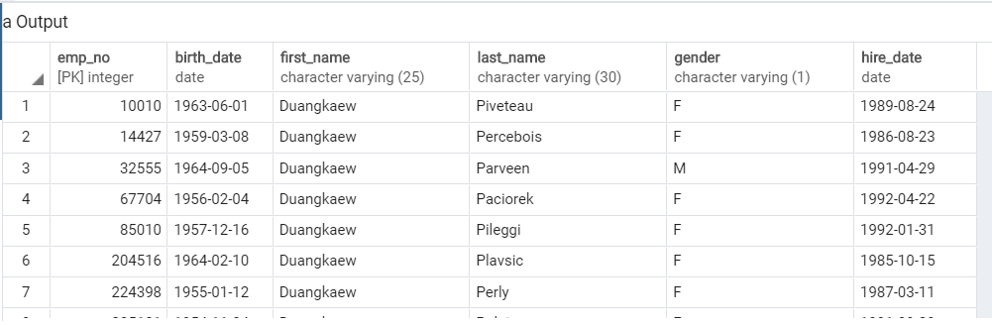

[6] List all employees in the Sales department, including their employee number, last name, first name, and department name.

SELECT e.emp_no, e.last_name, e.first_name, d.dept_name

FROM employees as e

INNER JOIN dept_emp as de

ON e.emp_no=de.emp_no

INNER JOIN departments as d

ON de.dept_no=d.dept_no

WHERE d.dept_name='Sales'

ORDER BY e.last_name;

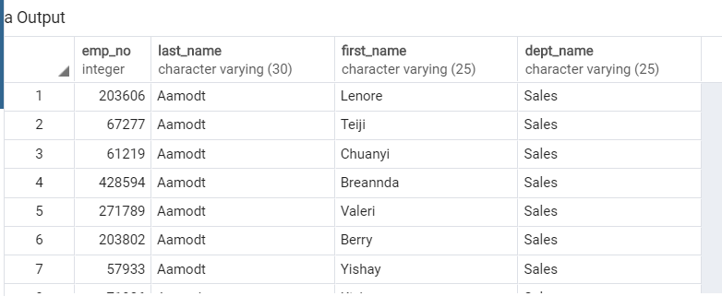

[7] List all employees in the Sales and Development departments, including their employee number, last name, first name, and department name.

SELECT e.emp_no, e.last_name, e.first_name, d.dept_name

FROM employees as e

INNER JOIN dept_emp as de

ON e.emp_no=de.emp_no

INNER JOIN departments as d

ON de.dept_no=d.dept_no

WHERE d.dept_name='Sales' OR d.dept_name='Development'

ORDER BY e.last_name;

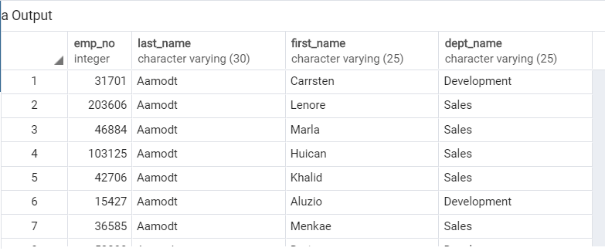

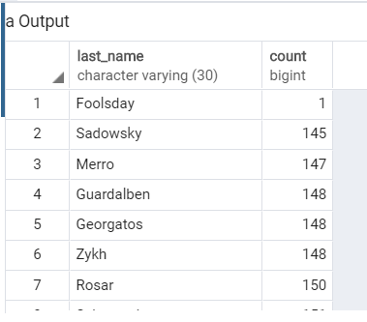[8] In ascending order, list the frequency count of employee last names, i.e., how many employees share each last name.

SELECT last_name,COUNT(*) as count

FROM employees

GROUP BY last_name

ORDER BY count;